The Solar Cycle(s): Bibliography review, data analysis and time series forecasting.

Space Environment, MAST, UPC-ETAAC

A solar cycle: a montage of ten years' worth of [Yohkoh](https://en.wikipedia.org/wiki/Yohkoh) SXT images, demonstrating the variation in solar activity during a solar cycle, from after August 30, 1991, to September 6, 2001. Credit: the Yohkoh mission of [ISAS](https://en.wikipedia.org/wiki/Institute_of_Space_and_Astronautical_Science) (Japan) and [NASA](https://en.wikipedia.org/wiki/NASA) (US).

When it comes to Space, the Solar Cycle (and in general, seasonality and patterns in nature) has always been one of my fascinations. Its behaviour is far from the simple 11-year periodicity that we might have heard of: it is actually incredibly more complex than that. Multiple combined cycles are believed to taking place, some of them spanning centuries or even millenia. Of course, these kind of observations and modelling only use indirect information, and are more on the descriptive side. To be able to generate an *explicative* model would require to fully understand the distribution and mechanics of the core of our star, and there is still work to be done. In the meantime, we will keep on studying these secondary phenomena, such as sun-spots, SPE, solar x-ray activity and UV readings, and collecting and analyzing the data that is available to us. This article aims to cover the background and history on solar observation, overview current methods and models, perform data analysis and model fittings on a publicly available (NOAA’s Solar Flare Index) dataset, and forecast future trends.

# The history of solar observation

The oldest eclipse records found date back to 1223 BCE, in Ugarit (now Syria), written down on a clay tablet. From that onwards, ancient Babylonians seem to have kept track of eclipses, even going as far as being able to predict them [1,6]. Sunspots were first observed around 800 BCE, both by Babylonians and the Chinese. These records were taken on command of the emperors, and noted some “darkenings” or “obscurate” patches in the Sun [1,6]. Five centuries later, similar readings were made by the Greek scholar Theophrastus [2].

During the Middle Ages, more and more observations were taken note of. Aldemus, in the year 807 CE, thought he was seeing Mercury pass in front of the Sun, but it was later found to be a notably large sunspot. He wasn’t the only one, since in the coming years more incorrect attributions to planets in transit took place [3]. Observations of the solar corona and of solar flares or CMEs happened, respectively, in the year 968 and in 1185, both during a solar eclipse [4,6].

During the Modern Era, Thomas Harriot, in 1610, was the first to observe sunspots with a telescope, with Johann Goldsmith confirming his sightings just a year later [5,6]. They both paved the way for Galileo Galilei, who claimed three years later that the sunspots were surface features of the Sun, and not planets or other celestial bodies [6]. The studies were slowed down by what we know of the Maunder Minimum, a period of low solar activity, with very few sunspots and CMEs.

In the early XIXth century, radiation (IR and UV) readings from the sun started being recorded, and solar spectrometry was born. Samuel Heinrich Schwabe was the first to theorize about a “ten-year Solar Cycle” based on sunspot activity. Gustav Spörer claimed that the cycle lasted around 70 years, attempting to explain the Maunder Minimum. Rudolf Wolf studied the past sunspot data and attempted to collect historical records for later studies. Later, independent researchers found a connection between this cycle and magnetic activity on Earth, becoming the first research into Earth-Sun interactions. [7]

During the XXth century, many solar observatories were built around the world, specializing in certain areas of the sun. Also, many satellites and probes have been launched to study solar activity. The f10.7 index (radio emissions of wavelength of 10.7cm) has been incredibly useful for solar activity recording. Other, more modern methods of indirect observation include looking into geology (rock formations, layering and magnetization) or carbon-14 decay in tree rings or ice sheets [8].

From then on, various independent scientists have been trying to predict solar activity and the behaviour of the “Solar Cycle”. There exist claims as different as saying that the 25th Cycle might not happen at all (NSO) [9], or that it will have the same intensity as Cycle24 [10] (NOAA).

# State of the art

NASA’s “Space Place” defines the Solar Cycle as “the cycle that the Sun’s magnetic field goes through approximately every 11 years. [...] the Sun’s magentic field completely flips. [...] (the Solar Cycle) affects activity on the surface of the Sun, such as sunspots [...]” [11]. There is, later again in the text, emphasis on the “approximation” of this 11-year period. And why is that?

Evolution of the Sun in extreme ultraviolet light from 2010 through 2020, as seen from the telescope aboard Europe's PROBA2 spacecraft. Credit: Dan Seaton/European Space Agency (Collage by NOAA/JPL-Caltech)

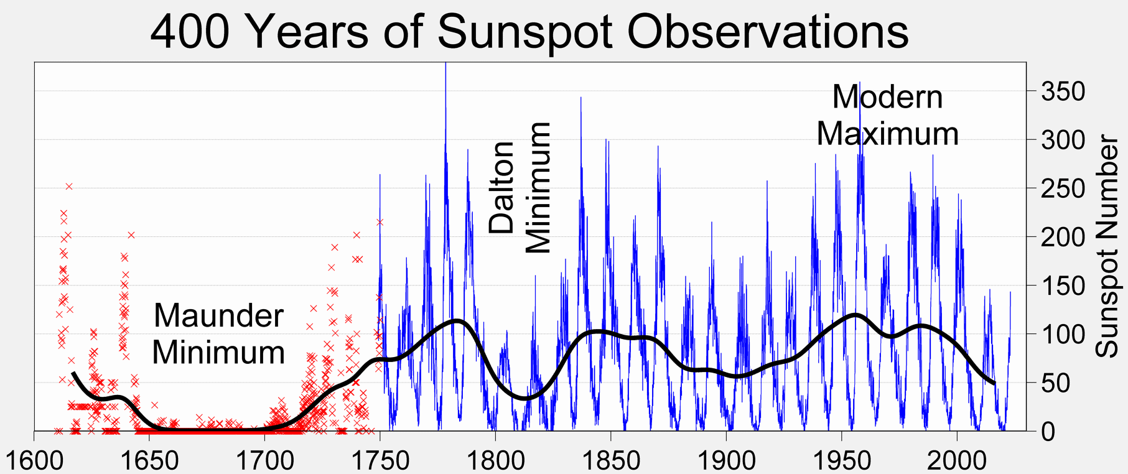The most recent studies [12] have determined that the Sun Cycle length has remained the same for at least 700 million years: around 10.62-11 years per flip. Still, many factors of this said cycle are still unknown to us: for example, a study in 2009 revealed that a very short cycle (less than 8 years) had taken place in the XVIIIth century, completely shaking up the feeling of stability and predictability that had reigned before [13]. Simply overviewing the historical records, one can see that said cycle is far from constant.

Plot showing historical sunspot records, by [Robert A. Rohde](https://en.wikipedia.org/wiki/User:Dragons_flight) (part of the Global Warming Art project).

Plenty of “effects” and modulating “patterns” have been theorized, trying to describe all these irregularities. As a summary:

* Waldeimer effect: Term coined after Max Waldeimer, who observed that the cycles’ maximum amplitude and the time between minimum and maximum are inversely proportional. So, the more “aggressive” and “violent” cycles also happen faster [14].
* Gleissberg cycle: it describes a broader, slower cycle of 70-100 years (so every seven or eight cycles) that modulates the activity of the 11-year cycles. This correlates well enough with data from carbon-14, used for the periods of time when there were no regular, systematic human observations taking place [8].
* Suess-de Vries cycle: this overarching cycle has only been observed in radiocarbon proxies (not by direct observation of sun-phenomena) and has a period of around 210 years. Still, since we only have 400 years of sunspot records, there isn’t still a correlation significant enough to validate it [8].

And this is where things get interesting. Larger, longer cycles could exist, but there are simply not enough records to confirm or deny their existance. Also, the composition and modulation of these effects, one on top of another, makes describing and modelling the solar cycle orders of magnitude more complex.

# Data Analysis: NOAA database

For this section, we will be using the data from the sun flare index from the National Centers for Environmental Information (formely the National Oceanic and Atmospheric Administration). The repository links and data folders, as well as all files, can be found in Annex I. As a quick side note, I would not recommend using this data directory as is, since the state of it was well below standards. I have curated and properly formatted the dataset in my GitHub repository, as well as uploaded all the source code and data. More information on this in Annex I.

The Flare Index Data used in this study was calculated by T.Atac and A.Ozguc from Bogazici University Kandilli Observatory, Istanbul, Turkey. They have done an amazing job at recording this invaluable information, and if it weren’t for them, these kind of data analysis and forecasts could not be performed.

As a summary, the Solar Flare Index (SFI) is TODO, and is a good indicator of solar activity.

We will start the study by displaying data in a daily, monthly, and yearly basis. This averages will allow us to see the unpredictability but also the periodicity of the Sun Cycles.

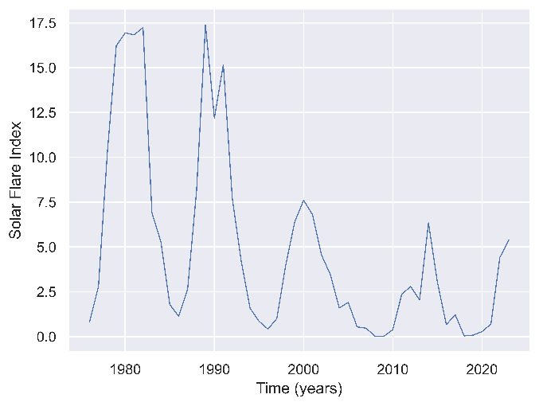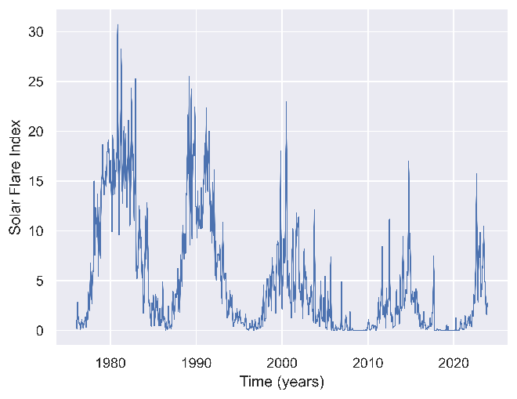Yearly and monthly Solar Flare Indices for the period of 1976-2023. Raw data by Kandili Observatory, processing and plots generated by me (Python, Seaborn and Matplotlib).

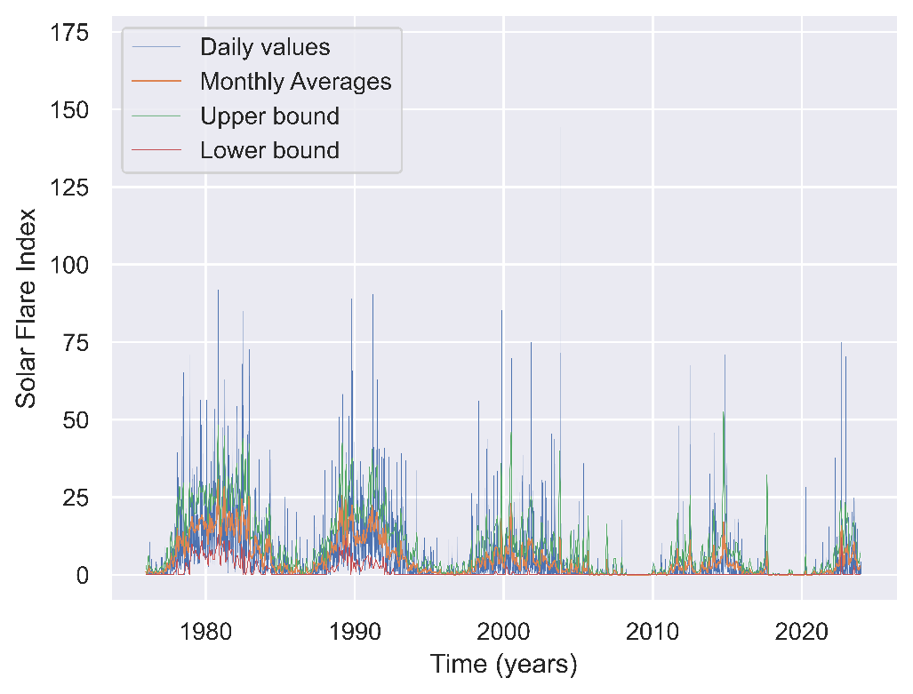And here is a full resolution visualization of the most fine-grained data available: the daily SFI records. I have also plotted the monthly data, in orange, as well as the plus-minus one sigma ranges (CI of 65%), with green (upper) and red (lower), calculating the variance on a monthly basis. This shows just how unpredictable these high energy peaks are.

Daily and monthly Solar Flare Indices for the period of 1976-2023. Raw data by Kandili Observatory, processing and plots generated by me (Python, Seaborn and Matplotlib).

Just by overviewing these plots, we can see the unpredictability that was described in the former sections. While the monthly average values don’t ever exceed SFI values of 30-32, the daily values can reach up to the 160s, more than five times higher. These high-energy events usually duplicate or triplicate the upper +1 sigma bound, exemplifying well how complicated are they to predict.

# Predicting Cycles 25 and 26. Time series forecasting.

Now, a time series data analysis would not be complete without some predictions and forecasting. We will use two methods for it: a SARIMA model and a compounded sinusoidal mathematical model.

The SARIMA model consists on the joint usage of an Auto-Regressive model, a Moving Average model, differentiation, and Seasonality. It is crucial that we use a SARIMA instead of an ARMA-ARIMA model, because (see Annex II) a model that doesn’t take into account seasonality will very likely not be able to properly represent a cyclic behaviour (like that of the Sun’s Cycle).

We have chosen a p=d=q=1, P=D=Q=1, s=12*11 as an initial guess. The AR and MA values are standard for time-series forecasting, and the seasonality factor was set to 12*11 (132 months, or eleven years), since we will be predicting values on a monthly basis. We also decided to differentiate once, in hopes of focusing on the variation between months instead of the actual SFI values per month. The resulting model, trained on 576 observations, had a log-likelihood value of -1223.6 and predicted the following years’ activity pretty realistically.

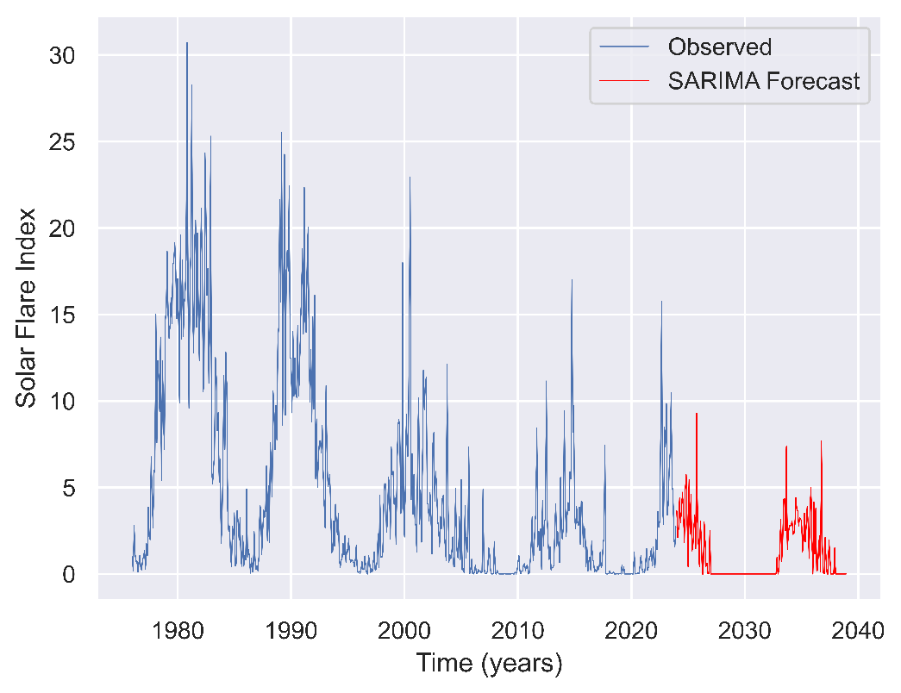

Prediction of the SARIMA model, generated by me (Python, Seaborn, Matplotlib, Numpy and Statsmodels).

We see a prediction similar to NOAA’s claims [10], which is that Cycle 25 will be very similar to Cycle 24. The model dared to also predict some peaks, portraying C25 as a double peaked cycle. Cycle 26 predictions seem conservative enough, with a wide minimum around the years 2027-2033.

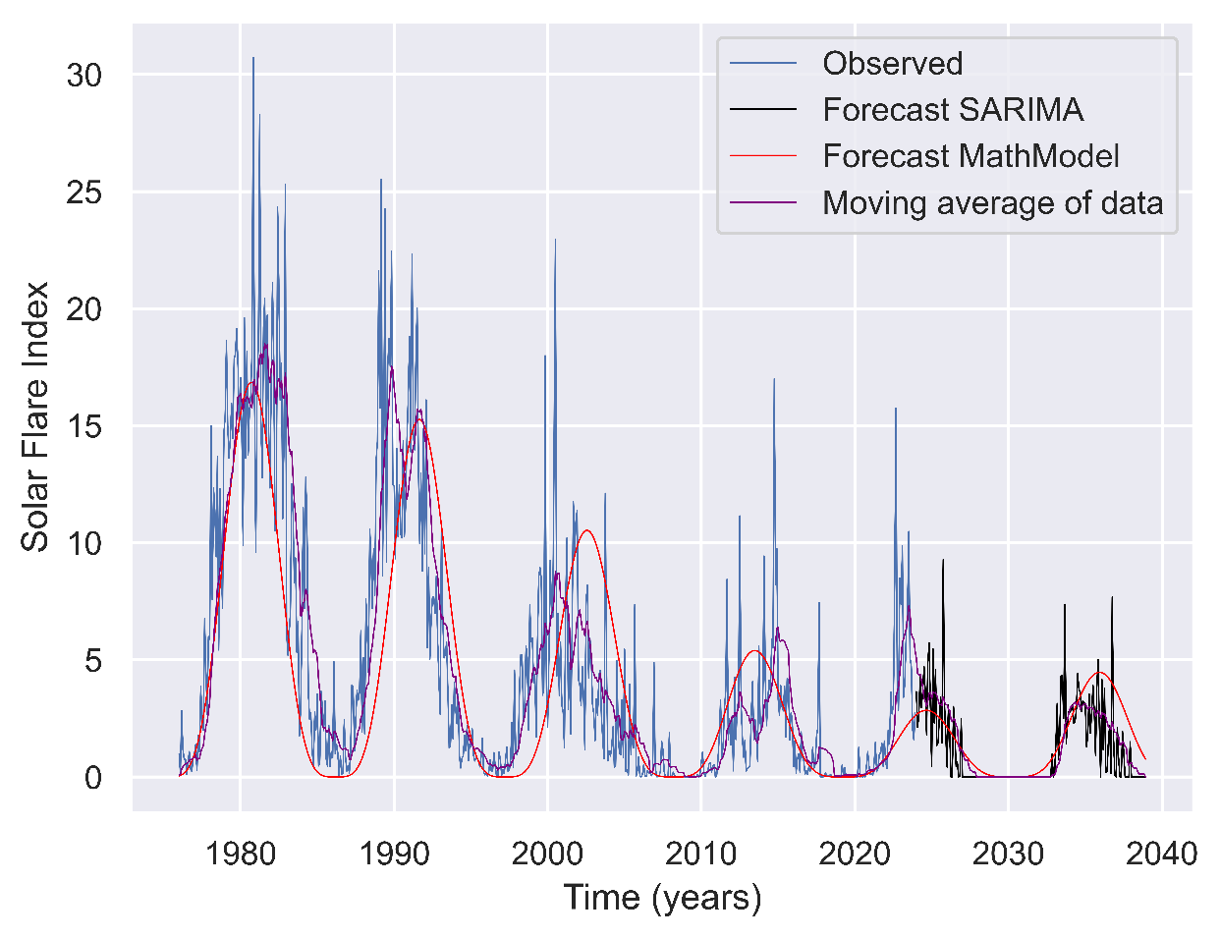Now, we also decided to construct a mathematical model utilizing a composition of sinusoidal waves. We decided to fit parameters for both the 11-year cycle and Gleissberg’s 70-100 year cycle, which we set to a period of 8 cycles (88 years). The results, while not showing any peaks, are satisfactory, and could model pretty well the yearly averaged SFI values for the forthcoming years.

Mathematical model predictions, plotted on top of the observed monthly data, a moving average window of 12 months, and SARIMA’s predictions. Generated by me (using Python, Seaborn, Matplotlib, Numpy and Statsmodels).

This model predicts a slight rise for Cycle 26 and a quiet Cycle 25. It also agrees with NOAA’s [10] opinion, but does steer more towards NSO’s prediction. It was very interesting to generate this model, because with a simple product of sinusoidals, we were able to perceive some effects in the peak’s time of appearance. The modulation of Gleissberg’s cycle shifted slightly forward and backward some of the peaks, which could be a way to explain some of the shortened or elongated cycles experienced in the past. The equation for it is as follows:

While the function is not simplified at all, I’ve written it this way to be able to show most parameters and how they interact with eachother. At its core, is a product of two cosines, the left one (squared) corresponding to the smaller cycle and the other one to Gleissberg’s, that stands above the horizontal axis (SFI values can’t be negative).

# Conclusions

I believe we have been able to, even if briefly, cover most of the history and current investigation lines regarding the Solar Cycle. In this article we have also taken time to explore the data ourselves, investigate and make some future predictions on the Sun’s activity for the following decades.

Studying the variability and unpredictability of the SF index was fascinating, and being able to represent data grouped by different time scales allowed us to both understand the underliying trend and the quick variations of the phenomena.

The status of the dataset, unfortunately, was very poor. The data itself, provided by NOAA and Kandilli Observatory, is precious and given with extreme detail and accuracy. Still, it is regrettable that it is provided in such a substandard shape and formatting. Luckily, this did not stop us from conducting the study, and we were able to provide a clean dataset for future users to utilize in their investigations.

We were able to make some predictions using several time-series models. The ARMA proved unsuccessful (see Annex II), but SARIMA yielded exciting results, agreeing with renowned institutions in the field. We were also able to theorize a mathematical model to represent the cycle’s long scale fluctuations with success.

As we mentioned at the beginning of the article, these predictions and models are based on indirect measurements, and not actually describing the internal movements of the Sun’s core and magnetic field. For us to be able to make predictions with confidence, we would need to mathematically model those fluid interactions in the star’s nucleus as well as corona, which is extremely complex as of today.

# References

[1] High Altitude Observatory (NCAR) education webpage <https://web.archive.org/web/20140818180023/http://www.hao.ucar.edu/education/TimelineA.php>

[2] J. British Astronomical Association (SAO-NASA-ADS), letter to the editor regarding Theophrastus’ observations <https://adsabs.harvard.edu/full/2007JBAA..117..346V>

[3] *Wilson ER (1917). "A Few Pre-Copernican Astronomers". Popular Astronomy.* ***25****: 88.*

[4] High Altitude Observatory (NCAR) education webpage <https://web.archive.org/web/20140818180026/http://www.hao.ucar.edu/education/TimelineB.php>

[5] Sunspot Positions and Areas from Observations by Thomas Harriot, Springer Nature <https://link.springer.com/article/10.1007/s11207-020-01604-4>

[6] High Altitude Observatory (NCAR), Great Moments in the History of Solar Physics <https://web.archive.org/web/20060301083022/http://web.hao.ucar.edu/public/education/sp/great_moments.html>

[7] High Altitude Observatory (NCAR) education webpage <https://web.archive.org/web/20140818180035/http://www.hao.ucar.edu/education/TimelineD.php>

[8] The Solar Cycle, David H. Hathaway, Springer Nature. <https://link.springer.com/article/10.12942/lrsp-2010-1>

[9] Commentary by NSO regarding upcoming reduced solar activity. <https://web.archive.org/web/20150802025816/http://www.boulder.swri.edu/~deforest/SPD-sunspot-release/SPD_solar_cycle_release.txt>

[10] NOAA’s Cycle-25 preliminary forecast, from 2019. <https://www.swpc.noaa.gov/news/solar-cycle-25-preliminary-forecast>

[11] NASA’s “Space Place” educational page <https://spaceplace.nasa.gov/solar-cycles/en/>

[12] NewScientist article by Michael Marshall <https://www.newscientist.com/article/2176487-rock-layers-show-our-sun-has-been-in-same-cycle-for-700-million-years/>

[13] Arxiv Astrophysics article by Usoskin et al, lost Cycle <https://arxiv.org/abs/0907.0063>

[14] Chinese J. of Astronomy and Astrophysics, “The Relation between the Amplitude and the Period of Solar Cycles” <https://iopscience.iop.org/article/10.1088/1009-9271/6/4/12>

# Annex I

Brief commentary on the status of the Flare Index Dataset (NOAA), Kandilli Observatory.

The dataset status is not satisfactory. It is hard and painfully slow to navigate (considered programming and using a webscraper, but ended up downloading files from 1976 to 2023 manually which took around an hour). The formatting is extremely inconsistent:

* Between years 1976 and 1995, there are inconsistencies with empty header lines.
* The text “FULL DISK” keeps shifting left and right throught all years.
* In 1996, the text “Kandili Observatory” appears in that (formerly) empty line
* In 2009, the “2009” text shifts to the BOL, instead of being trailed by some whitespaces like all years prior to that.
* 2010 changes dots “.” by commas “,” and also changes whitespaces by tabs.
* 2011 reverts back to dots, but now introduces several extra empty lines in the header (mixed with the information). It also keeps using tabs.
* 2022 introduces three extra lines to the file header, regarding the university’s information. It also eliminates blank lines between days 5-6, 10-11, etc.

I would like to remark that having access to precious data like this is extremey helpful for research, and that by no means I’m trying to disregard or undermine the work done by Kandil Observatory and Bogazici University. I do believe, though, that it is a pity that such accurate and important data as this has become complicated to utilize due to poor maintenance.

In this repository I share a python script which is able to clean up and reformat the data. Feel free to use it or tweak it if needed.

## GitHub repository with code and clean dataset

https://github.com/Nerocraft4/SolarCycleStudySFI

## Dataset references

Dataset Source: <https://www.ngdc.noaa.gov/stp/space-weather/solar-data/solar-features/solar-flares/index/flare-index/>

Dataset Documentation: <https://www.ngdc.noaa.gov/stp/space-weather/solar-data/solar-features/solar-flares/index/flare-index/documentation/dataset-discription_flare-index.pdf>

Dataset Calculations: <https://www.ngdc.noaa.gov/stp/space-weather/solar-data/solar-features/solar-flares/index/flare-index/documentation/solar-physics_atac-ozguc.pdf>

# Annex II

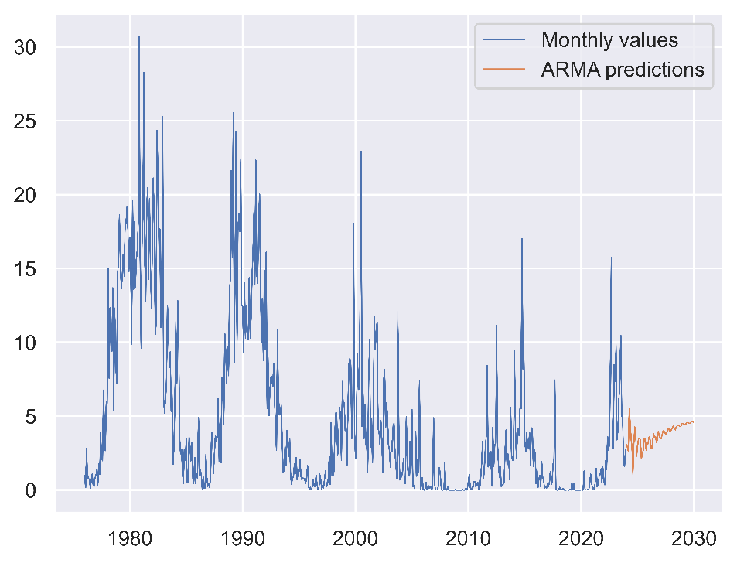Here are the (disastrous) results of fitting an ARMA-ARIMA model with NOAA’s solar cycle data, and why using a SARIMA is key for representing cyclic, repetitive events.

Even taking it to the extreme (an ARMA with 24 coefficients in the AutoRegressor), the ARMA model is uncapable of properly predicting what will happen next. We would need at least 12*11 132 coefficients (information from last cycle), which would encumber the model in useless calculations and end up yielding a mediocre result. Here’s the ARMA model’s equation:

As we can see, it is split between the first terms (constant and time-based error) and the two sums. The first one represents the AutoRegressive part (multiplying lagged values of the series by some coefficient) and the other the Moving Average (working with lagged errors or residuals).

SARIMA, on the contrary, also includes seasonal information: that is, values lagged an entire season behind. So while ARMA is only working with, let’s say, the past *p* months, SARIMA has information on the last *p* months, as well as information of the past *P* months corresponding to the last cycle. This way, it can easily detect if it’s “falling off” from the seasonal trend, and quickly correct itself.